# Double-ended queue documentation

## Description

The double-ended queue is an abstract data type - a linear collection that supports element insertion and removal at both ends. Basically, the Deque combines the functionality of both queue and stack data structures. Said formally, Deque generalizes a queue, for which elements can be added to or removed from either the front (head) or back (tail). Normal Deque implementations place no fixed limits on the number of elements they may contain.

## Implementation

The implementation of the deque requires an inheritance of the IDeque<T> interface. The interface consists of the following methods and properties:

• **int Count** – returns the number of elements in the Deque;

• **void PushFirst(T element)** - inserts element at the beginning of the Deque;

• **void PushLast(T element)** - inserts element at the end of the Deque;

• **T PopFirst()** - removes and returns the element at the beginning of the Deque;

• **T PopLast()** - removes and returns the element at the end of the Deque;

• **T PeekFirst()** - returns the element at the beginning of the Deque without removing it;

• **T PeekLast()** - returns the element at the end of the Deque without removing it;

• **void Clear ()** - clears the Deque. It will be empty after this operation completes;

• **bool Contains(T element)** - returns true if this collection contains the specified element;

By creating the class Deque.cs and inheriting the interface mentioned above, the methods in the interface should be implemented in the class, so that the double-ended queue inherits the interface functionality.

The methods are implemented as it follows:

Int Count():

public int Count()

{

return this.data.Count();

}

Void PushFirst(T item):

public void PushFirst(T item)

{

this.data.AddFirst(item);

}

Void PushLast(T item)

public void PushLast(T item)

{

this.data.AddLast(item);

}

T PopFirst():

public T PopFirst()

{

var firstItem = this.data.First;

this.data.RemoveFirst();

return firstItem.Value;

}

T PopLast():

public T PopLast()

{

var lastItem = this.data.Last;

this.data.RemoveLast();

return lastItem.Value;

}

T PeekFirst():

public T PeekFirst()

{

return this.data.First.Value;

}

T PeekLast():

public T PeekLast()

{

return this.data.Last.Value;

}

Void Clear():

public void Clear()

{

this.data.Clear();

}

Bool Contains(T item):

public bool Contains(T item)

{

if (this.data.Find(item).Value.Equals(true))

{

return true;

}

else

{

return false;

}

}

# Methods

|  |  |  |
| --- | --- | --- |
|  | **Name** | **Description** |
| Public method | [Clear](ms-its:C:\Users\maria\Desktop\WS&C\DoubleEndedQueueImplementation\DequeueDocumentation\Help\DequeueDocumentation.chm::/html/7a0e62cb-f185-3b4f-5ce3-245adb7c3164.htm) | Clears all items from the dequeue. |
| Public method | [Contains](ms-its:C:\Users\maria\Desktop\WS&C\DoubleEndedQueueImplementation\DequeueDocumentation\Help\DequeueDocumentation.chm::/html/4fdc5165-09c1-3625-7782-68c1f2ee12a7.htm) | Returns a value indicating whether the specified T item occurs within this dequeue. |
| Public method | [Equals](http://msdn2.microsoft.com/en-us/library/bsc2ak47) | Determines whether the specified [Object](http://msdn2.microsoft.com/en-us/library/e5kfa45b) is equal to the current [Object](http://msdn2.microsoft.com/en-us/library/e5kfa45b).  (Inherited from [Object](http://msdn2.microsoft.com/en-us/library/e5kfa45b).) |
| Protected method | [Finalize](http://msdn2.microsoft.com/en-us/library/4k87zsw7) | Allows an object to try to free resources and perform other cleanup operations before it is reclaimed by garbage collection.  (Inherited from [Object](http://msdn2.microsoft.com/en-us/library/e5kfa45b).) |
| Public method | [GetHashCode](http://msdn2.microsoft.com/en-us/library/zdee4b3y) | Serves as a hash function for a particular type.  (Inherited from [Object](http://msdn2.microsoft.com/en-us/library/e5kfa45b).) |
| Public method | [GetType](http://msdn2.microsoft.com/en-us/library/dfwy45w9) | Gets the [Type](http://msdn2.microsoft.com/en-us/library/42892f65) of the current instance.  (Inherited from [Object](http://msdn2.microsoft.com/en-us/library/e5kfa45b).) |
| Protected method | [MemberwiseClone](http://msdn2.microsoft.com/en-us/library/57ctke0a) | Creates a shallow copy of the current [Object](http://msdn2.microsoft.com/en-us/library/e5kfa45b).  (Inherited from [Object](http://msdn2.microsoft.com/en-us/library/e5kfa45b).) |
| Public method | [PeekFirst](ms-its:C:\Users\maria\Desktop\WS&C\DoubleEndedQueueImplementation\DequeueDocumentation\Help\DequeueDocumentation.chm::/html/fce69158-46d6-cebc-b4dc-d3156cf4d180.htm) | Gets the item at the head of the dequeue. |
| Public method | [PeekLast](ms-its:C:\Users\maria\Desktop\WS&C\DoubleEndedQueueImplementation\DequeueDocumentation\Help\DequeueDocumentation.chm::/html/0ddde524-2950-356e-9d64-a60c008c0b2c.htm) | Gets the item at the tail of the dequeue. |
| Public method | [PopFirst](ms-its:C:\Users\maria\Desktop\WS&C\DoubleEndedQueueImplementation\DequeueDocumentation\Help\DequeueDocumentation.chm::/html/d57ea2ce-3a7e-80e5-2079-9b438fdc9514.htm) | Removes an item from the head of the dequeue. |
| Public method | [PopLast](ms-its:C:\Users\maria\Desktop\WS&C\DoubleEndedQueueImplementation\DequeueDocumentation\Help\DequeueDocumentation.chm::/html/947adaa5-7fc5-6534-554b-59b3702c8171.htm) | Removes an item from the tail of the dequeue. |
| Public method | [PushFirst](ms-its:C:\Users\maria\Desktop\WS&C\DoubleEndedQueueImplementation\DequeueDocumentation\Help\DequeueDocumentation.chm::/html/de7816fa-78ff-26b0-0848-8f2966fdf436.htm) | Adds an item to the head of the dequeue. |
| Public method | [PushLast](ms-its:C:\Users\maria\Desktop\WS&C\DoubleEndedQueueImplementation\DequeueDocumentation\Help\DequeueDocumentation.chm::/html/4de08793-daba-31e6-02b8-791ecd7be7f1.htm) | Adds an item to the tail of the dequeue. |
| Public method | [ToString](http://msdn2.microsoft.com/en-us/library/7bxwbwt2) | Returns a string that represents the current object.  (Inherited from [Object](http://msdn2.microsoft.com/en-us/library/e5kfa45b).) |

## System requirements

|  |  |
| --- | --- |
| Operating system | Windows 7, Windows XP |
| .Net Framework | Version 4.5 |
| Visual Studio | 2012 |
|  |  |
|  |  |

## Example

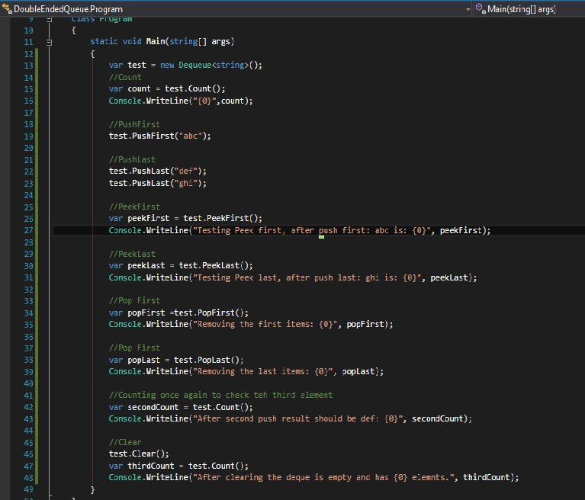

Result:

